FRONT DESK STAFF: Understanding and Using P-5 paperwork
P-5 Paperwork:
There are TWO types of P-5 paperwork:
- The pediatric registration, health history, and ROI
- The visit-specific questionnaires (These questionnaires ask about child health, similar to information gathered with adult patients using SBIRT or PHQ-9)
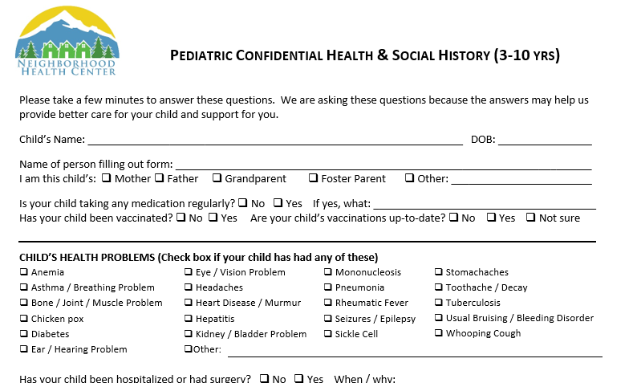
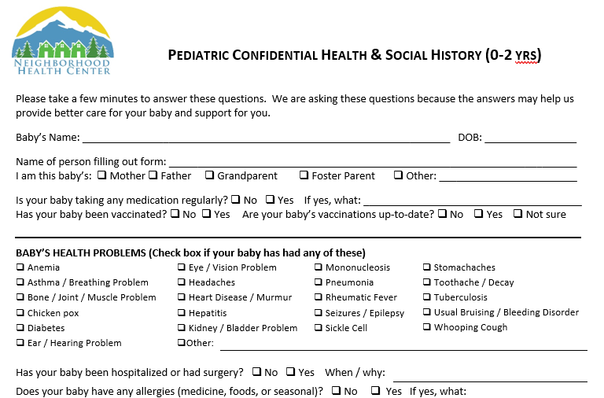
EXAMPLES OF REGISTRATION, HEALTH HISTORIES, AND ROI

Pediatric HHX 0-2 YEARS
Pediatric HHX 3-10 YEARS

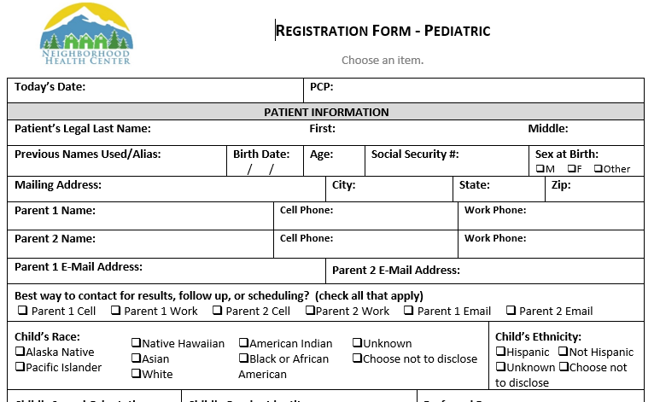
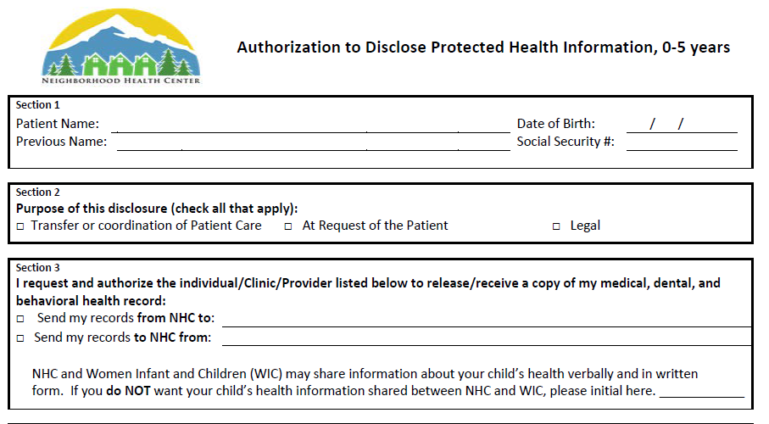

Pediatric REGISTRATION
Pediatric ROI

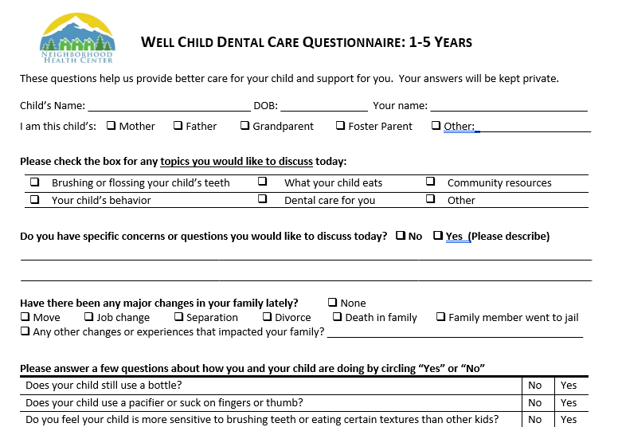
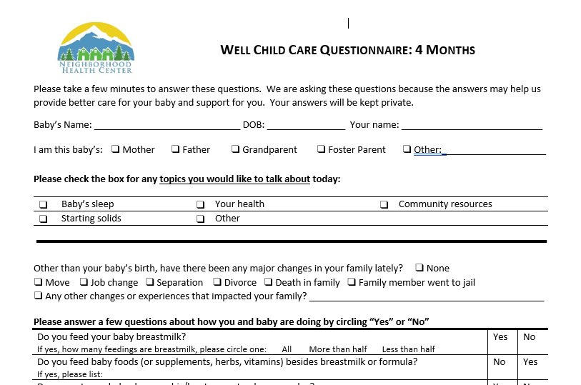
EXAMPLES OF VISIT SPECIFIC QUESTIONNAIRES

P-5 DENTAL QUESTIONNAIRE

P-5 WCC QUESTIONNAIRE

P-5 Paperwork General Info:
- All P-5 forms are stored in top right file cabinet behind FD.
- FD lead prints these forms regularly to keep them stocked.
- All forms can be found at Z:\NHC Forms
- If the patient has already filled out the P-5 Health History, Registration, and ROI forms in a medical visit within the past year, these do not need to be filled out at the first dental visit, and vice versa.
P-5 Paperwork Title and Desciption:
P-5 REGISTRATION FORM
- This form should be used for all 0-10 year old patients instead of the adult Registration form.
- This form should be used by both medical and dental.
P-5 HEALTH HISTORY FORM
- There are 2 versions of this form
- For 0-2 year olds
- For 3-10 year olds
- This form should be used for all 0-10 year old patients instead of the adult health history forms.
- This form should be used by both medical and dental patients because it combines the medical and dental HHX into one form.
P-5 ROI
- This form should be used for all 0-5 year old patients instead of the adult ROI
- This form should always be signed by the family, even if they are not requesting records by sent or received, because we use this form to communicate between NHC and WIC.

P-5 DENTAL VISIT QUESTIONNAIRE
- This questionnaire should be used for all 0-5 years old patients seen in dental for an establishing visit AND for each wellness check up after that. You do not give this form if the patient is seen for a filling, a sick visit, or an emergency.
P-5 MEDICAL WCC VISIT QUESTIONNAIRES
- These forms should be used for all WCC Visits for children birth to 5 years old.
- These questionnaires are similar to the P-5 Dental Visit Questionnaire described above, but these are for medical patients and are broken apart by age; so there are fifteen different questionnaires based on the child’s age.
- P-5 Coordinator prints these forms from the K: drive. If unavailable, Medical FD should print.
- How to know which age questionnaire to give in WCC visits: MA’s scrub for which age WCC visit questionnaire should be given and will add to the appointment “messages.”
- FD staff: Be sure to check appointment message to know which age questionnaire to use for each WCC visit.
P-5 Paperwork Scanning
FD staff to collect and scan the following documents:
- P-5 Registration – First visit only
- HIPAA*
- PHI*
- Income Verification Form (Only complete with POI)*
- P-5 ROI (please request the family reads, signs)
MA’s and DA’s will print barcodes and submit for scanning after visit for:
- P-5 Health History Form
- P-5 Dental Visit Questionnaire
- P-5 Medical WCC Visit Questionnaires
P-5 Paperwork When to Use
NEW PATIENTS:
- P-5 Registration – First visit only
- HIPAA*
- PHI*
- Income Verification Form (Only complete with POI)*
- P-5 Health History**
- P-5 ROI (please request the family reads, signs)
- Visit questionnaires (see box immediately below)**
- P-5 Dental Visit Questionnaire**
- P-5 Medical Visit Questionnaires (there are 15 questionnaires.)**
RETURNING PATIENTS (all wellness visits):
- P-5 Dental Visit Questionnaire**
- P-5 Medical Visit Questionnaires (there are 15 questionnaires.)**
TO BE UPDATED ANUALLY:
- HIPAA*
- SOGI*
- P-5 HHX**
- P-5 ROI

*Same as the adult version
**Pt brings this completed questionnaire into the visit to give to MA/DA.
**Cut out and tape at front desk for quick reference.**
P-5 PATH CHEAT SHEET
P-5 PATH = (Prenatal to 5 years old Patient Activation Toward Health)
Patients: pregnant moms, babies, kids under 5yr
Team care: Doctor, Occupational Therapist, coordinator, dentist and dental hygienist
Scheduling
- Put pts on OT’s schedule 20 minutes AFTER visit with Dr.
- Put pts on OT’s schedule at SAME time as the dental visit.
- There are 2 P-5 pt DENTAL appt blocks every Tues at 9 &3, for any medical pt in P-5 PATH who needs a dental checkup.
- Our dental hygienist is available in WCC visits every Monday between 1-5pm.

Checking In
Use P-5 Paperwork for ALL kids 0-5 coming in for a Well Child Visit OR a Dental visit. (Located in filing cabinet behind you) This is NOT the same paperwork as NHC’s standard new patient intake forms. All forms available in Spanish.
Forms
3 types of forms:
- Health Hx & Registration packet (same in Medical & Dental)
- WCC questionnaire- 0-5 yrs in medical (based on age)
- Dental questionnaire- 0-5 yrs in dental (1 for all ages)

?’s about which forms to use- ask OT or coordinator.

