Dental Anxiety Scale Flowsheet

- Click on the Rooming tab in Epic. Click on Dental Anxiety Scale. This tab will only be present if due annually and for patients 10 years and older.

- Fill out the Dental Anxiety Scale with the patient.

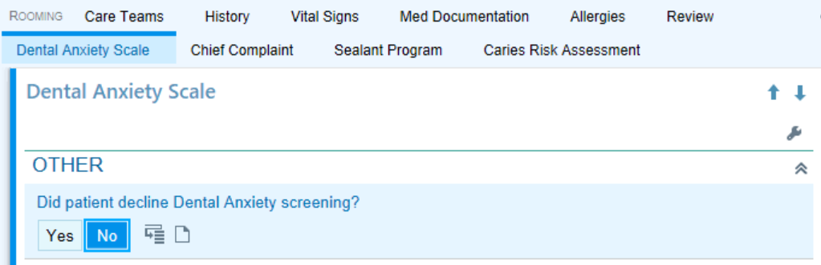
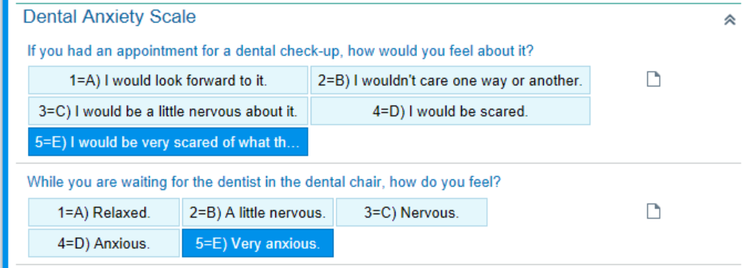
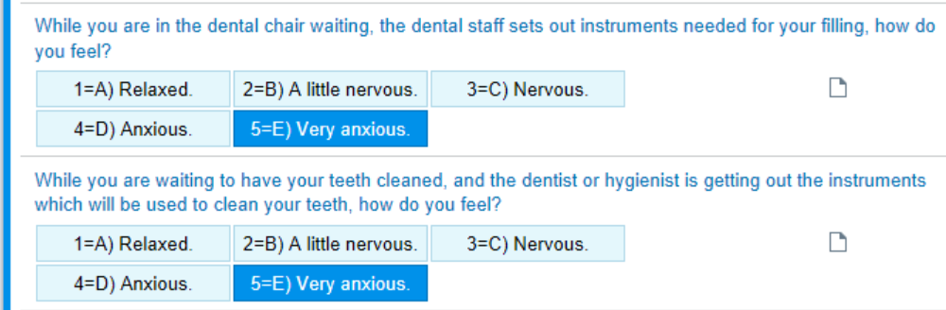
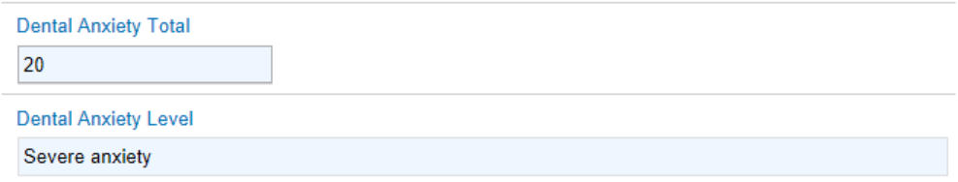
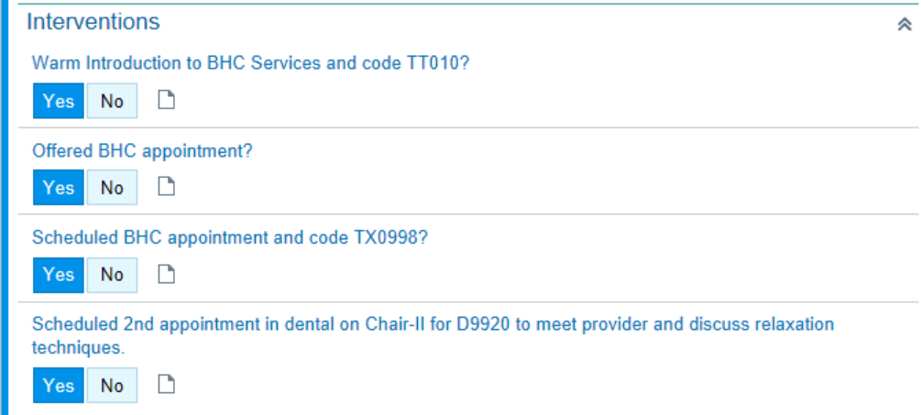

- Once the Dental Anxiety Scale is filled out and the new patient or recall clinical exam template is opened, the clinical note will auto populate with the results.

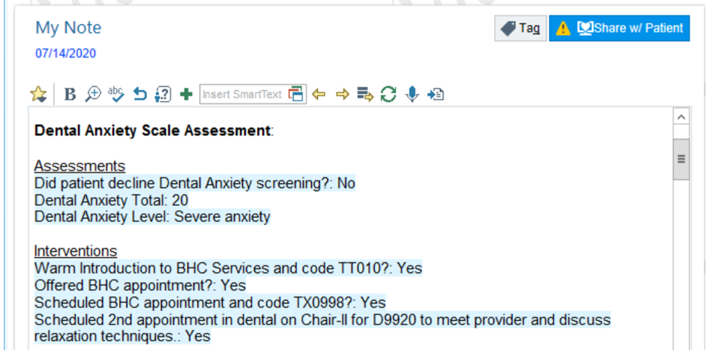

- You may revisit the Dental Anxiety Scale Flowsheet in Rooming and change any selection. Click refresh and your note will refresh with an updated score.

